MY BOURBON COLLECTION
Your Digital Bourbon Journey Starts Here

📱 Track Your Collection
• Catalog your bourbon bottles
• Record proof and purchase dates
• Add tasting notes and flavor profiles
• Store bottle photos
• Track purchase prices

🎯 Key Features
• Easy-to-use interface
• Sort by name, proof, or purchase date
• Search your entire collection
• Custom photo capture for each bottle
• Beautiful, modern design

�� Only $1.99
A small investment for the perfect bourbon companion

Perfect for:
• Bourbon enthusiasts
• Collectors
• Tasting groups
• Liquor store owners
• Gift givers

"Keep your bourbon journey organized and accessible"

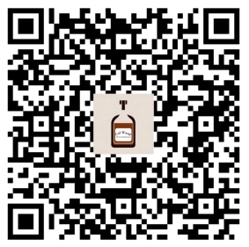
Col Wood says “Download Now” - Available on the App Store

